Christmas in America
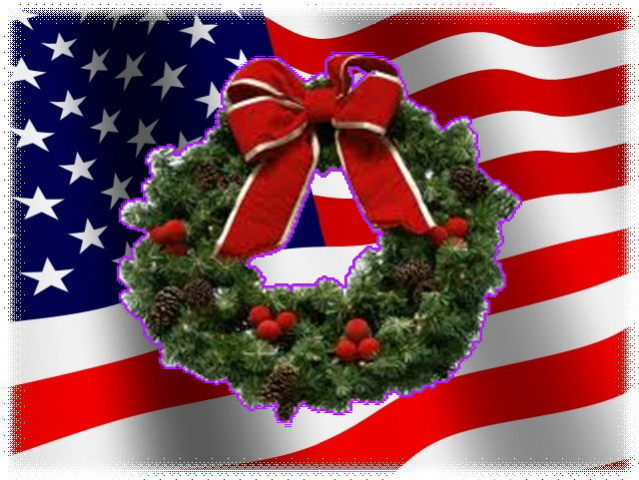
America is often called the 'melting pot', as it has a mixed bag of traditions from countries across the world. Christmas celebrations in the USA exemplify a perfect blend of customs mainly from countries such as England and Australia that introduced them to carols, Germany who familiarized the Americans to Christmas trees, Latin America that gave them the concept of parades and also, the Netherlands that introduced them to Santa Claus.

City Of Lights
Weeks before Christmas, houses are decorated with trees that are beautified with coloured lights, tinsels, bright ornaments, stars and angels. Electric lights are installed in homes, commercial buildings and business centers too. Santa Claus, snowmen and reindeers form a major part of the festivities.

The Legend Of Santa Claus
The story of Santa Claus originated in the United States in 1860's. This name was based on the Dutch word, St. Nicholas. Santa Claus did not become famous until the novelist, Washington Irving, wrote about him in 1809. Santa Claus was made popular in his reddish suit, reindeer, pipe and sleigh.

Read the information above and answer the questions
- What did different countries introduce in America?
England: ________________________________________________
Germany: _______________________________________________
Latin America: ____________________________________________
the Netherlands: __________________________________________
- How do American cities transform around Christmas?
____________________________________________________________________
- Where does the word ‘Santa Claus’ come from?
____________________________________________________________________
- How did Santa Claus become famous?
____________________________________________________________________

